**Student Name: Shinde Smita**

**UID: 20BCS4643**

**Date of Performance:17/02/2021**

**Branch: CSE-(IOT) Section/Group:IOT- Group B**

**Subject Name:Digital Eletronics**

**Aim :** Validation of truth tables of logic gates (NAND, NOR, AND, OR, NOT, XOR).

Validate truth table for:

* NAND gates HD74LS00
* NOR gates HD74LS02
* NOT gates HD74LS04
* AND gates HD74LS08
* XOR gates HD74LS86

**Task to be done:**

Validation of Truth tables and discussion of different kinds of logic gates by the help of circuit diagrams and truth tables.

**Requirements:**

**Hardware:-** IC for 7400, 7402, 7404, 7408, 7486, breadboard, connecting wires, power supply, resistor, LED.

**Software:** Tinkercad

**Circuit diagram/ Block diagram**

**For NAND GATE:-**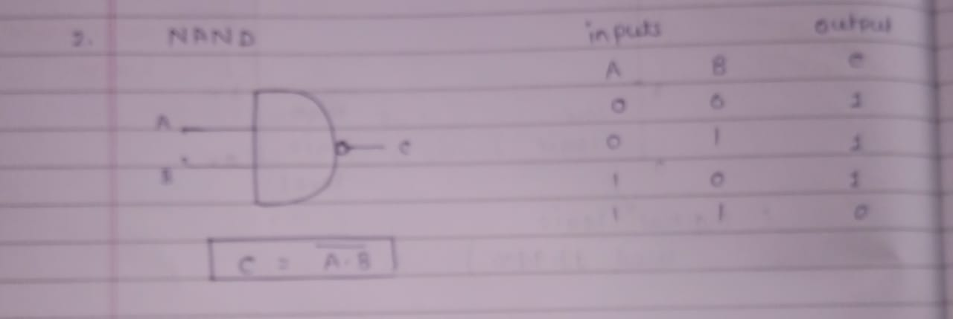

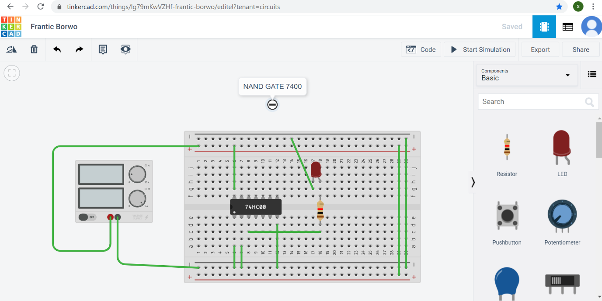

**FOR AND GATE:-**

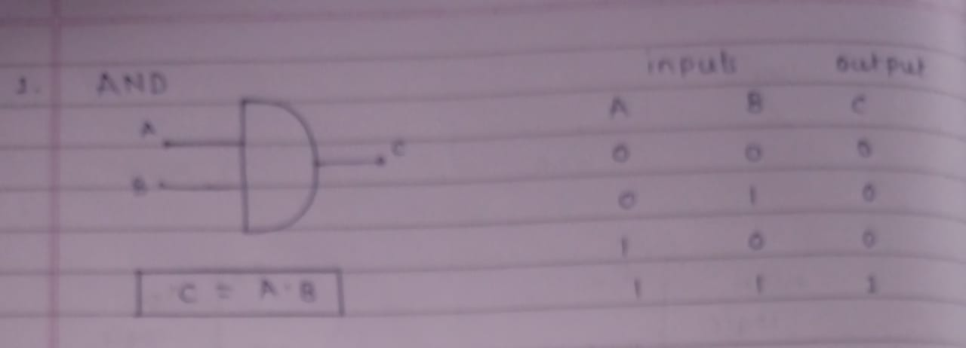

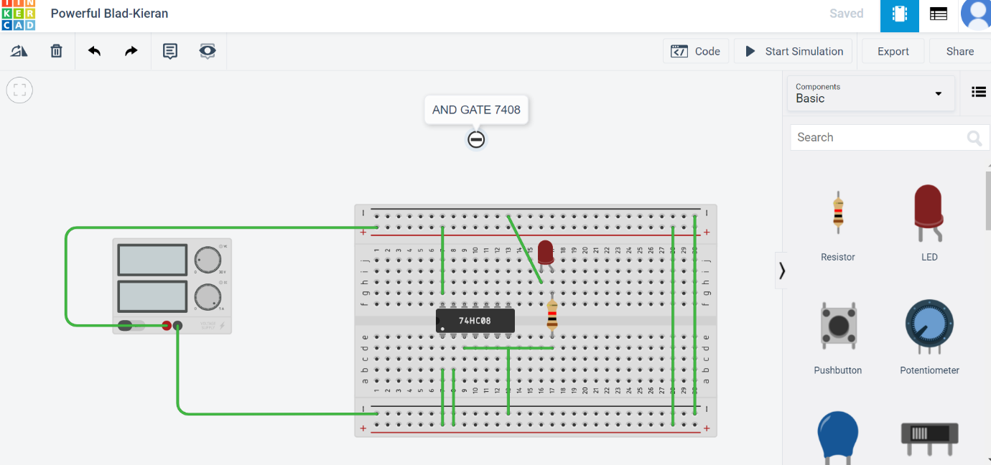

**FOR NOR GATE :-** 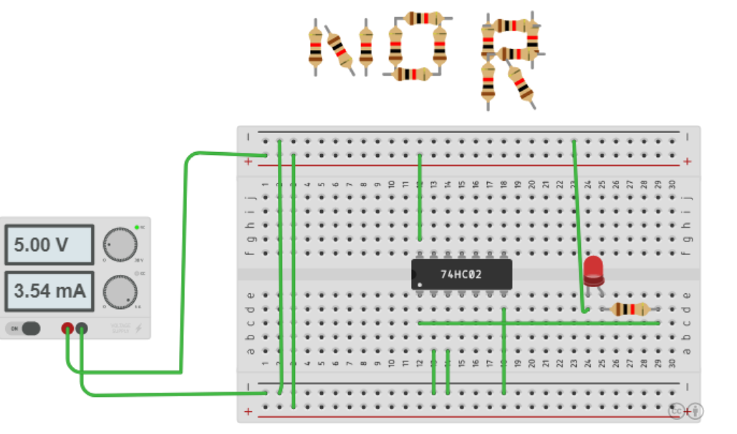

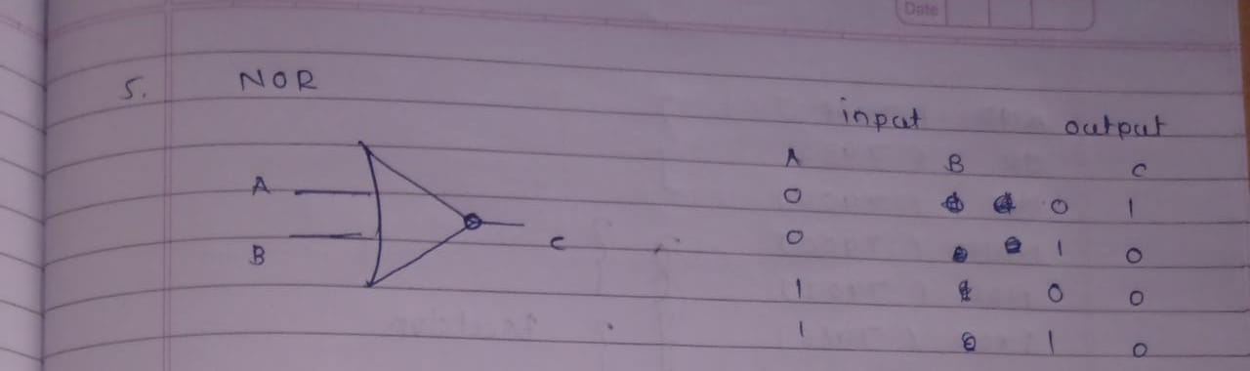

**FOR NOT GATE:-**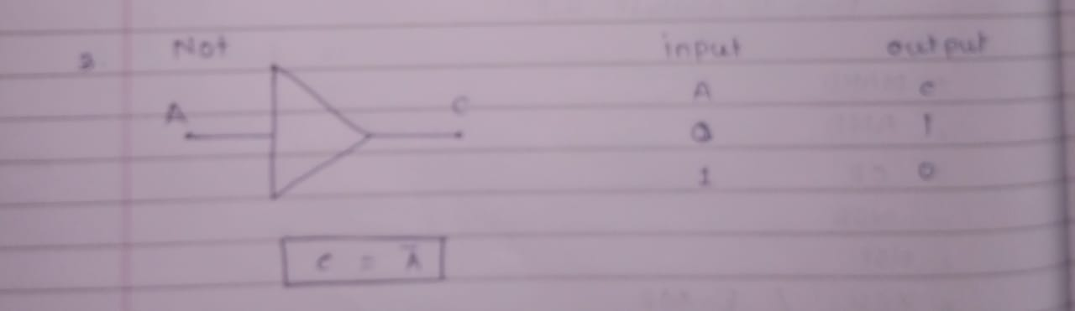

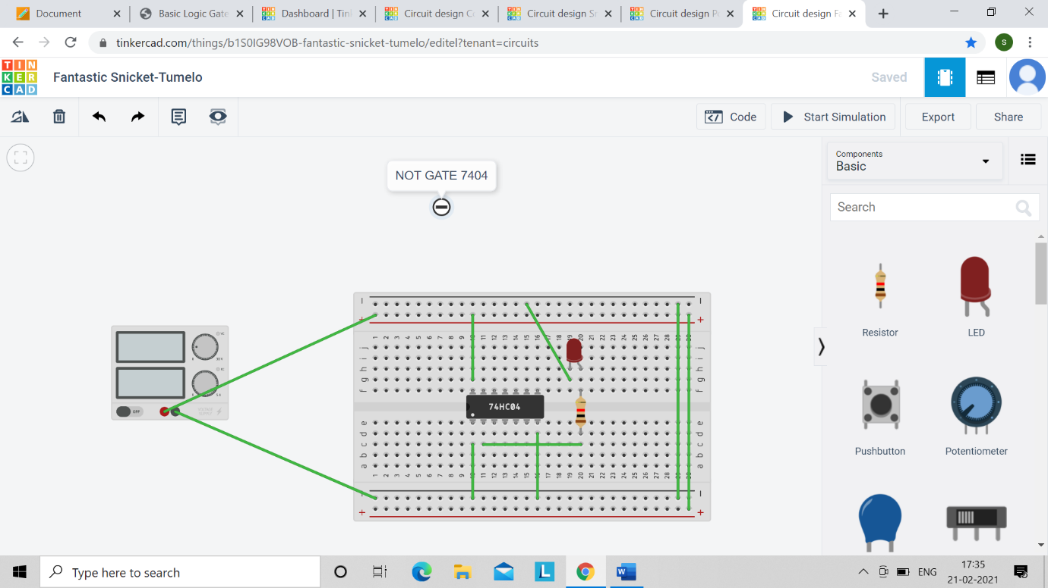

**FOR OR GATE:-**

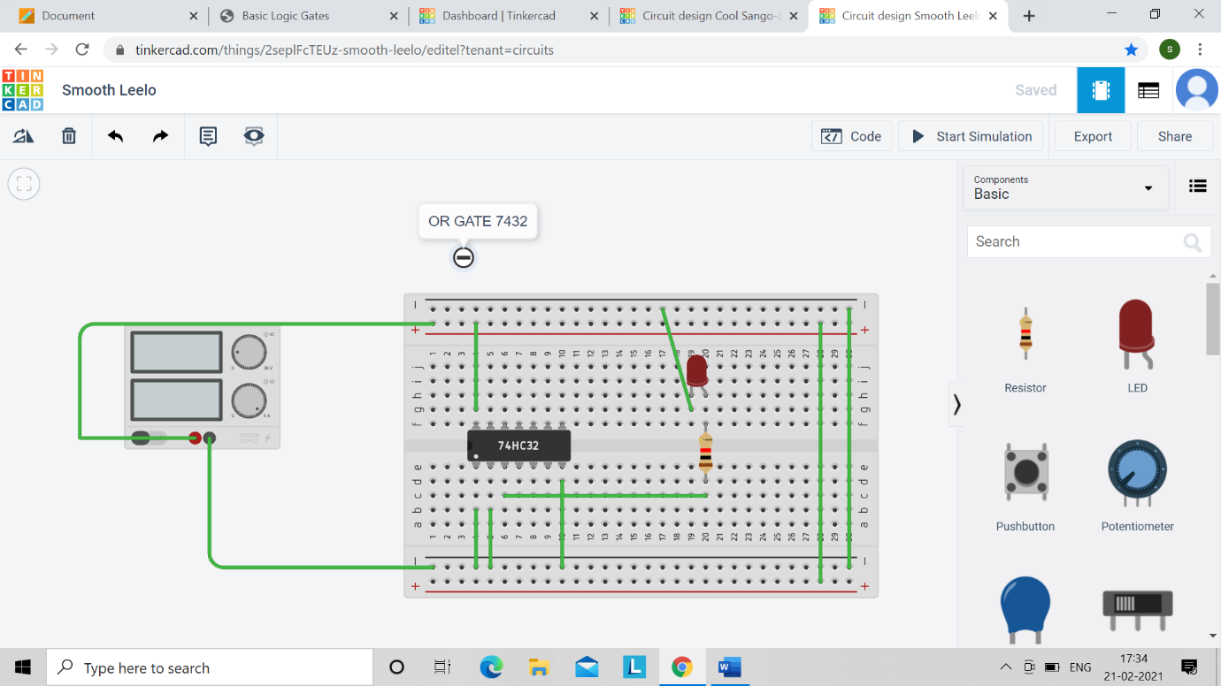

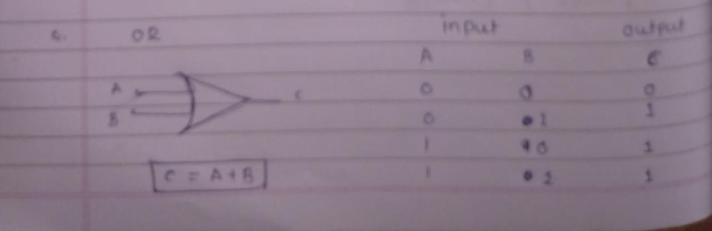**FOR XOR GATE:-**

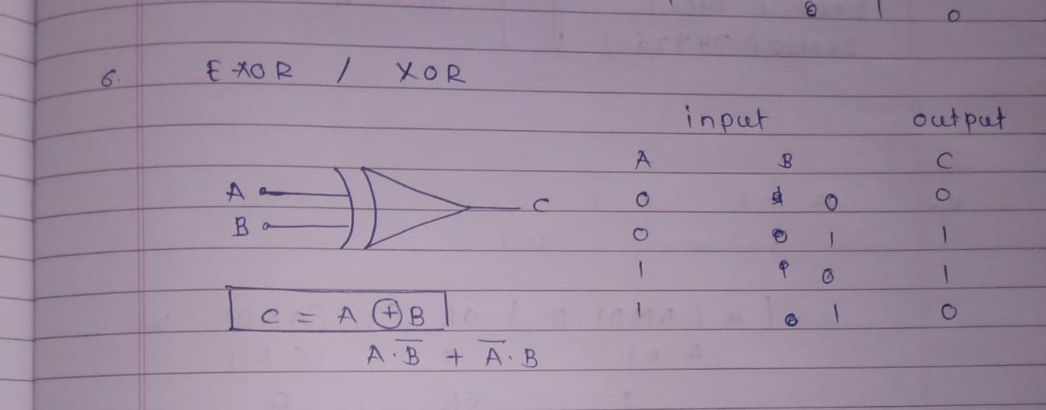

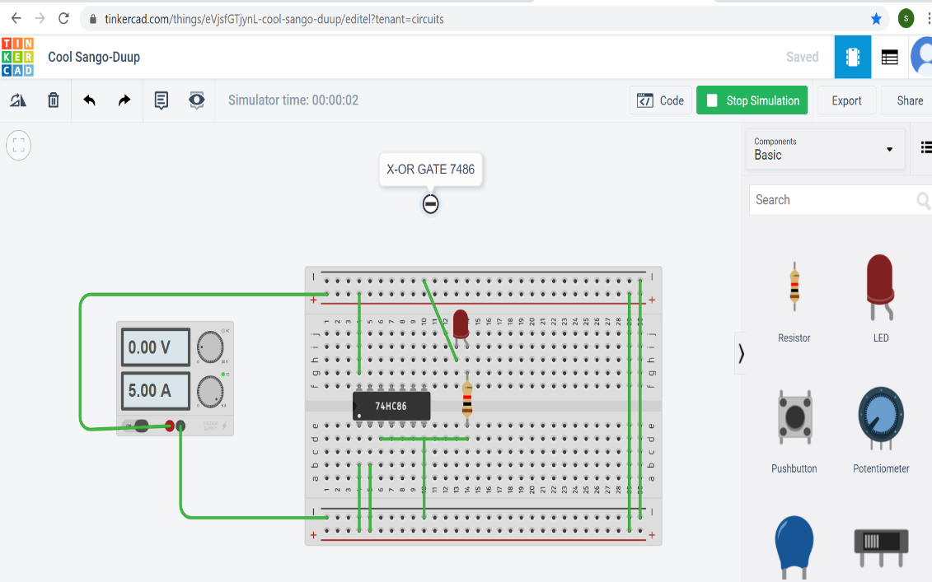

**Simulation Results**

**For NAND gate:-**

**Both inputs🡪HIGH, OUTPUT🡪LOW**

**One input🡪LOW & other input🡪HIGH, OUTPUT🡪 HIGH**

**One input🡪HIGH & other input🡪LOW, OUTPUT🡪HIGH**

**Both inputs🡪LOW, OUTPUT🡪HIGH**

**For NOR gate:-**

**Both inputs**→**HIGH, OUTPUT**→ Low

**One input**→**LOW & other input**→**HIGH, OUTPUT**→ Low

**One input**→**HIGH & other input**→**LOW, OUTPUT**→ Low

**Both inputs**→**LOW, OUTPUT**→ High

**For NOT gate:-**

**input**→**HIGH, OUTPUT**→ Low

**input**→**LOW, OUTPUT**→ High

**For AND gate:-**

**Both inputs**→**HIGH, OUTPUT**→ High

**One input**→**LOW & other input**→**HIGH, OUTPUT**→ Low

**One input**→**HIGH & other input**→**LOW, OUTPUT**→ Low

**Both inputs**→**LOW, OUTPUT**→ Low

**For XOR gate:-**

**Both inputs**→**HIGH, OUTPUT**→ Low

**One input**→**LOW & other input**→**HIGH, OUTPUT**→ High

**One input**→**HIGH & other input**→**LOW, OUTPUT**→ High

**Both inputs**→**LOW, OUTPUT**→ Low

**Concept used:**

The concepts used here are none other than binary logics like how to deal with binary logics with variables to get a logical meaning out of them.

**Learning/ observation**

The truth tables of logic gates NAND, NOR, AND, NOT, XOR was verified.

**Troubleshooting**

One should be very careful and sure about Boolean expressions of logic gates and must remember the IC number of the resp. logic gate